Illustration by Abi
quirky and individual designs

all of my products have been designed using my hand drawn pen & ink illustrations
my cards and homewares have been printed and manufactured in the uk
products have been selected for quality of finish paying attention to use of natural materials
my branding is luxurious and consistent throughout the entire product range
every item is carefully packaged and presented beautifully for the end customer

wholesale pricelist (minimum order x4 of any product)

greeting cards £1.30 RRP £2.50-3
15cm square, blank inside, printed on 300g conqueror contour card stock, supplied with recycled kraft envelope and cello sleeve with branded sticker and branding on card reverse

‘Classic Dogs’
City Dogs Country Dogs Beach Dogs Forest Dogs
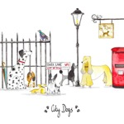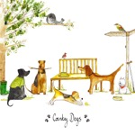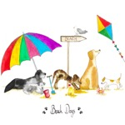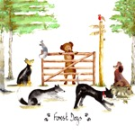

‘Themed Dogs’
(valentines/xmas also available)
Birthday Condolence Mother’s Day
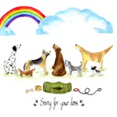

‘Lots of…’
Lots of Dogs Lots of Cats Lots of Spotty Dogs
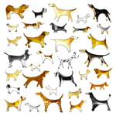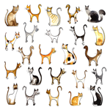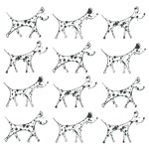

‘Dog Breeds’
Labrador Schnauzer Spaniel Terrier
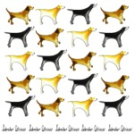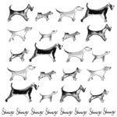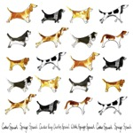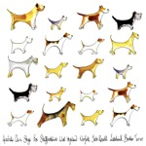

Pg 1

notecard packs £4 RRP £8
a6 reversible postcards x10, printed on 200g cream card stock, supplied with recycled kraft envelopes, ribbon wrapped and sealed in cello sleeve with branded sticker

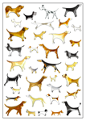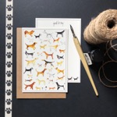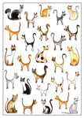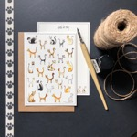

tea towels £6 RRP £10-12
100% cotton large tea towels, with a hand stitched branded label, large hanging loop and presented wrapped in a branded belly band

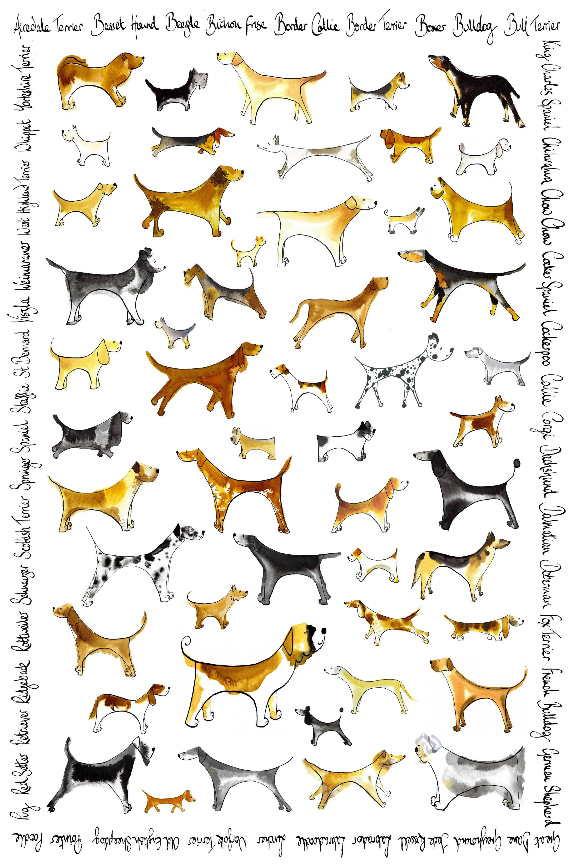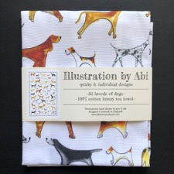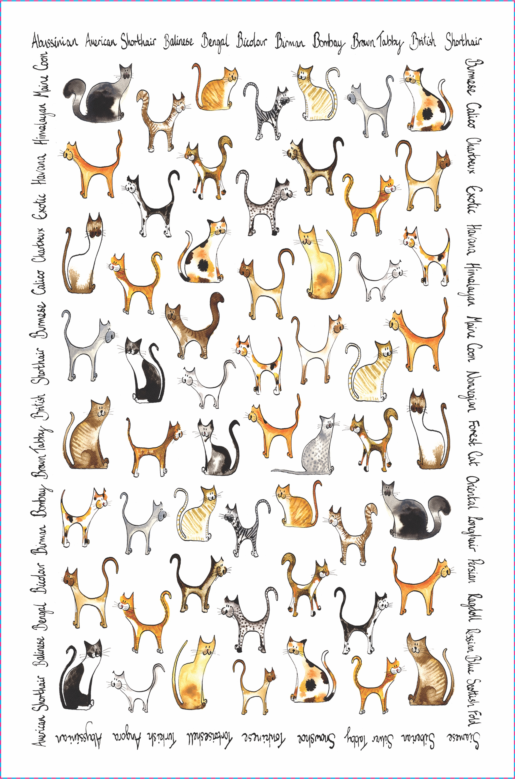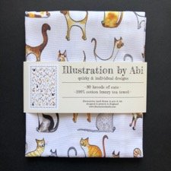

mugs £7.50 RRP £12-14
large 12oz high quality bone china mugs, hand stamped with logo on bottom, dishwasher & microwave safe, presented with string tied kraft swing tag on handle and delivered in kraft boxes with window, ribbon wrapped with branded sticker

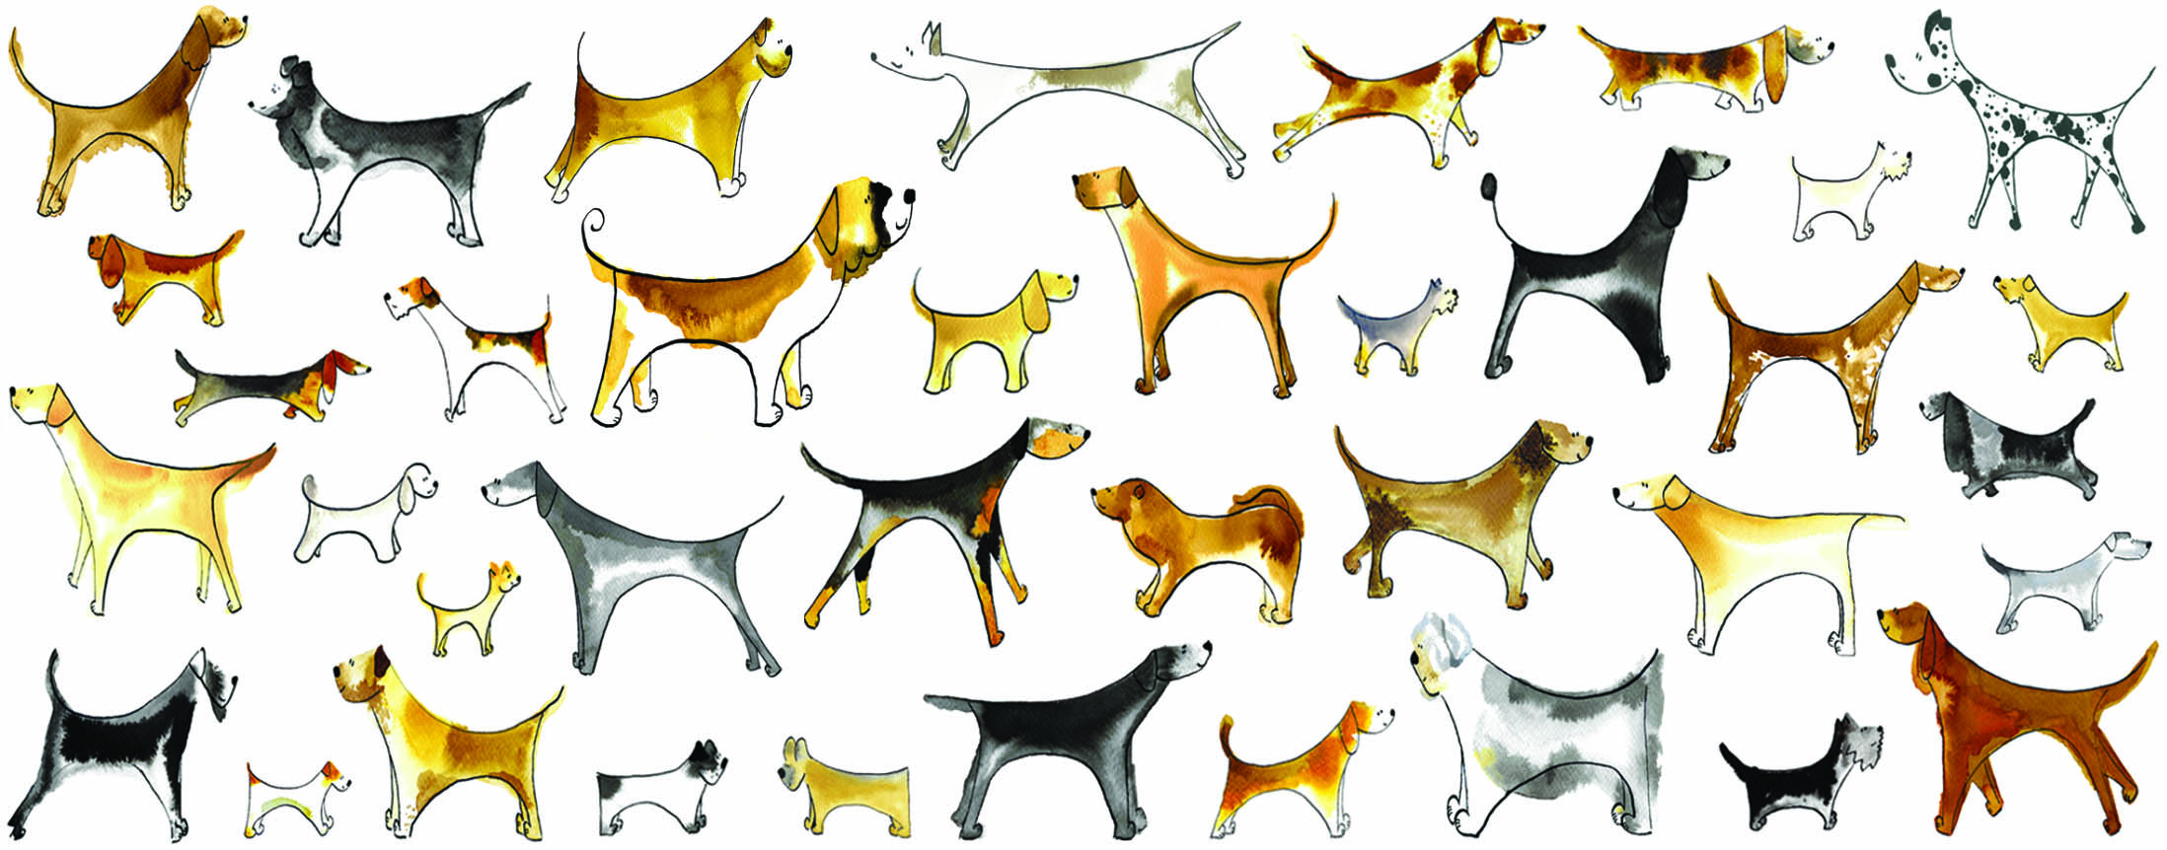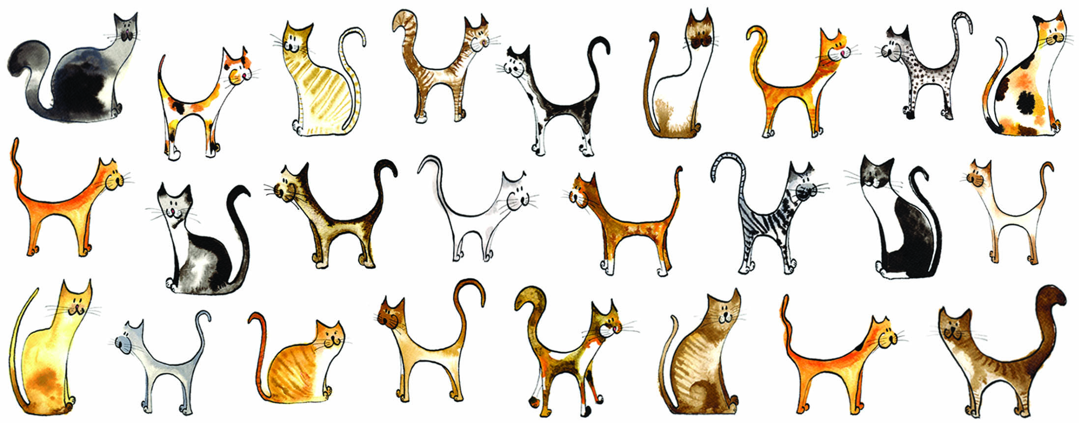
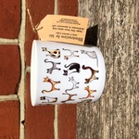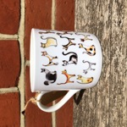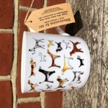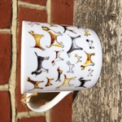

tote bags £8.50 RRP £14-16
100% cotton long handled luxury tote bags, with a hand stitched branded label, contrasting black handles, designed on both sides and presented folded with a branded swing tag
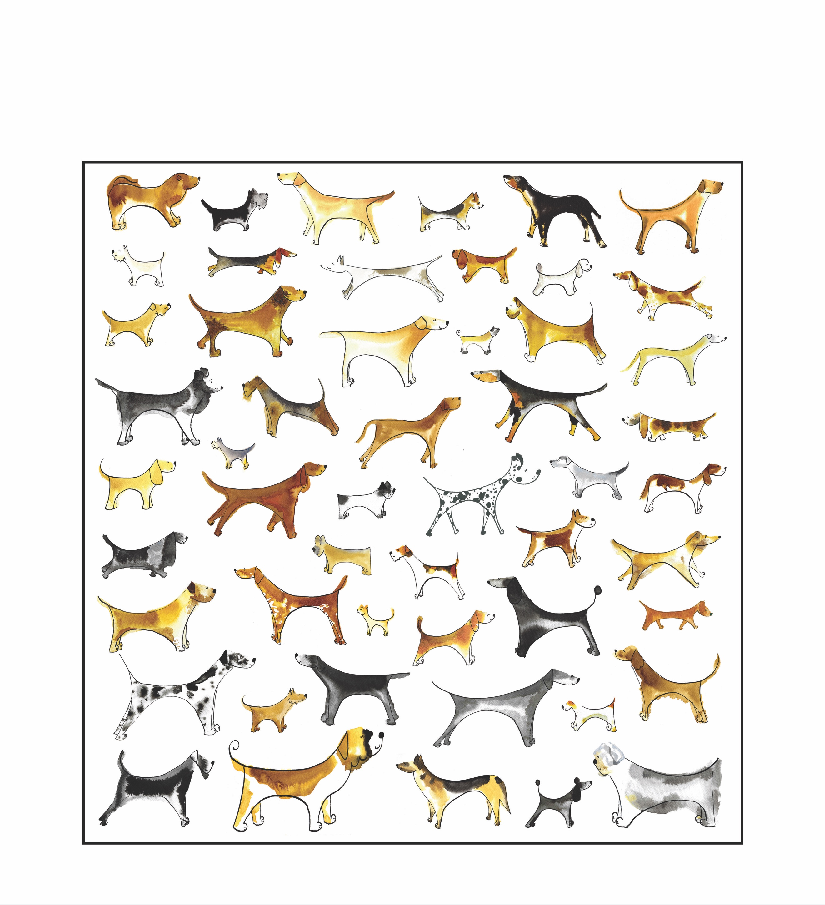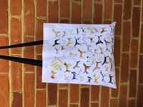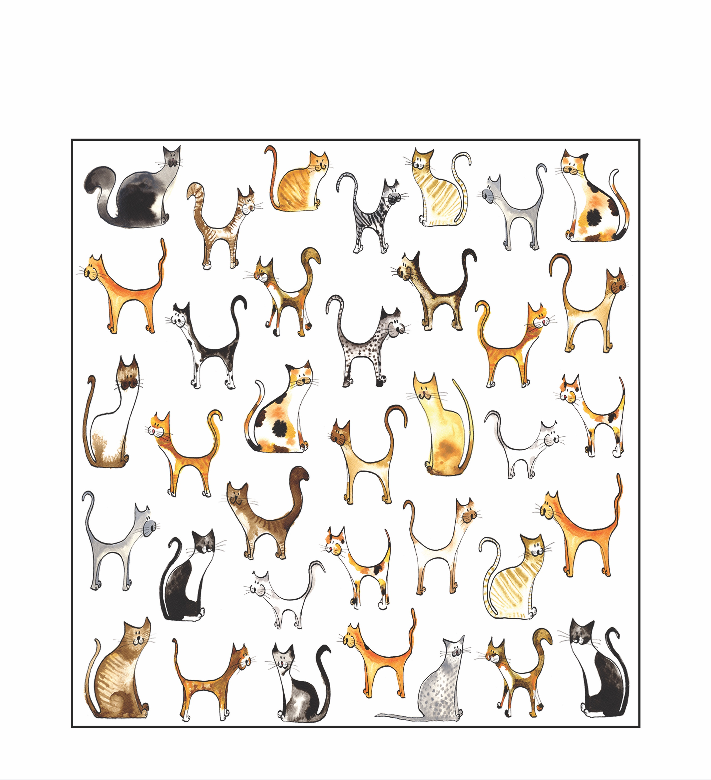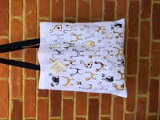

Pg 2

coasters £7 RRP £12
pack of 4 coasters, wooden backed, durable and wipeable gloss top, presented string tied with a branded label

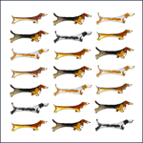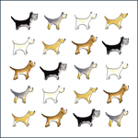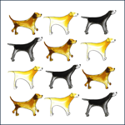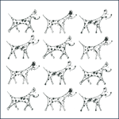

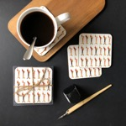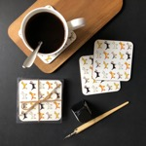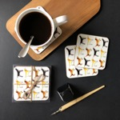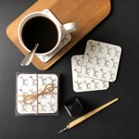

postage
if you are local I will try to deliver your orders to you when possible but I cannot guarantee this and may have to charge you postage. i prefer to use Royal Mail since they provide the best parcel postage service and include full contents compensation. postage and packaging will be included separately on your invoice.

invoicing
for your very first order I will need payment up front but from then on I am happy to offer re-orders and re-stocking on a 30 day invoice. paypal or bank transfer is acceptable.

current stockists include:
Bumbles in Ashtead
Indigo Stripes in Bookham
Eden Florists in Leatherhead
The Framing Workshop in Ashtead
Thor’s Paws grooming parlour in Mickleham
Love From Betty in Guildford
4 Paws Boutique Spa in Cranleigh
Puppy Love Pet Store in Ringwood

Pg 3

